### Semester Two Examination, 2016

### Question/Answer Booklet

# MATHEMATICS

**SOLUTIONS**

**METHODS**

**UNITS 1 AND 2**

## Section One:

## Calculator-free

|  |  |  |  |  |  |  |  |  |
| --- | --- | --- | --- | --- | --- | --- | --- | --- |
| Student Number: In figures |  |  |  |  |  |  |  |  |

In words

Your name

## Time allowed for this section

Reading time before commencing work: five minutes

Working time for section: fifty minutes

## Materials required/recommended for this section

***To be provided by the supervisor***

This Question/Answer Booklet

Formula Sheet

***To be provided by the candidate***

Standard items: pens (blue/black preferred), pencils (including coloured), sharpener, correction fluid/tape, eraser, ruler, highlighters

Special items: nil

## Important note to candidates

No other items may be taken into the examination room. It is **your** responsibility to ensure that you do not have any unauthorised notes or other items of a non-personal nature in the examination room. If you have any unauthorised material with you, hand it to the supervisor **before** reading any further.

## Structure of this paper

|  |  |  |  |  |  |
| --- | --- | --- | --- | --- | --- |
| Section | Number of questions available | Number of questions to be answered | Working  time (minutes) | Marks available | Percentage of exam |
| Section One:  Calculator-free | 8 | 8 | 50 | 52 | 35 |
| Section Two:  Calculator-assumed | 12 | 12 | 100 | 98 | 65 |
|  | | | **Total** | 150 | 100 |

## Instructions to candidates

1. The rules for the conduct of examinations are detailed in the school handbook. Sitting this examination implies that you agree to abide by these rules.

2. Write your answers in this Question/Answer Booklet.

3. You must be careful to confine your response to the specific question asked and to follow any instructions that are specified to a particular question.

4. Spare pages are included at the end of this booklet. They can be used for planning your responses and/or as additional space if required to continue an answer.

* Planning: If you use the spare pages for planning, indicate this clearly at the top of the page.
* Continuing an answer: If you need to use the space to continue an answer, indicate in the original answer space where the answer is continued, i.e. give the page number. Fill in the number of the question that you are continuing to answer at the top of the page.

5. **Show** **all your working clearly**. Your working should be in sufficient detail to allow your answers to be checked readily and for marks to be awarded for reasoning. Incorrect answers given without supporting reasoning cannot be allocated any marks. For any question or part question worth more than two marks, valid working or justification is required to receive full marks. If you repeat any question, ensure that you cancel the answer you do not wish to have marked.

6. It is recommended that you **do not use pencil**, except in diagrams.

7. The Formula Sheet is **not** to be handed in with your Question/Booklet.

Section One: Calculator-free 35% (52 Marks)

This section has**eight (****8)** questions. Answer **all** questions. Write your answers in the spaces provided.

Working time for this section is 50 minutes.

Question 1 (4 marks)

A box contains a total of 500 marker and highlighter pens of various colours, as shown in the table. Some of the marker pens are permanent and the rest are non-permanent.

|  |  |  |  |  |
| --- | --- | --- | --- | --- |
|  | Colour | | | |
| Type of pen | Black | Yellow | Pink | Green |
| Permanent marker | 55 | 83 | 40 | 24 |
| Non-permanent marker | 45 | 67 | 24 | 12 |
| Highlighter | 0 | 50 | 46 | 54 |

A pen is selected at random from the box. Determine the probability that it is

(a) a yellow pen. (1 mark)

|  |
| --- |
| **Solution** |
| $$\frac{83+67+50}{500}=\frac{200}{500}=\frac{2}{5}$$ |
| **Specific behaviours** |
| ✓ correct probability |

(b) a marker pen. (1 mark)

|  |
| --- |
| **Solution** |
| $$\frac{500-\left(50+46+54\right)}{500}=\frac{350}{500}=\frac{7}{10}$$ |
| **Specific behaviours** |
| ✓ correct probability |

(c) a yellow pen or a marker pen. (1 mark)

|  |
| --- |
| **Solution** |
| $$\frac{200+350-83-67}{500}=\frac{400}{500}=\frac{4}{5}$$ |
| **Specific behaviours** |
| ✓ correct probability |

(d) a green pen, given that it is a highlighter. (1 mark)

|  |
| --- |
| **Solution** |
| $$\frac{54}{50+46+54}=\frac{54}{150}=\frac{9}{25} (=0.36)$$ |
| **Specific behaviours** |
| ✓ correct probability |

Question 2 (6 marks)

(a) Determine $f'(x)$ when $f\left(x\right)={\left(x-5\right)}^{2}$. (2 marks)

|  |
| --- |
| **Solution** |
| $$f\left(x\right)=\left(x-5\right)\left(x-5\right)=x^{2}-10x+25 \\ f^{'}\left(x\right)=2x-10$$ |
| **Specific behaviours** |
| ✓ expands  ✓ differentiates |

(b) Simplify

(i) $\frac{d}{dx}\left(5x^{2}-4x+3\right)$. (1 mark)

|  |
| --- |
| **Solution** |
| $$10x-4$$ |
| **Specific behaviours** |
| ✓ differentiates all terms |

(ii) $\lim_{h→0}{\frac{{\left(x+h\right)}^{4}-x^{4}}{h}}$. (1 mark)

|  |
| --- |
| **Solution** |
| $$\frac{d}{dx}x^{4}=4x^{3}$$ |
| **Specific behaviours** |
| ✓ differentiates |

(c) Calculate the gradient of the curve $y=2x^{5}-3x^{4}$ where $x=-1$. (2 marks)

|  |
| --- |
| **Solution** |
| $$\frac{dy}{dx}=10x^{4}-12x^{3} \\ \frac{dy}{dx}=10+12=22$$ |
| **Specific behaviours** |
| ✓ differentiates  ✓ substitutes and simplifies |

Question 3 (8 marks)

(a) The equations $x^{3}+x^{2}+ax+b=0$ and $x^{3}-bx^{2}-ax+4=0$ both have $x=2$ as a solution. Determine the values of $a$ and $b$. (4 marks)

|  |
| --- |
| **Solution** |
| $$8+4+2a+b=0⇒2a+b=-12 …(1) \\ 8-4b-2a+4=0⇒4b+2a=-12 …(2) \\ \left(2\right)-\left(1\right): 3b=24⇒b=8 \\ \left(1\right):2a+8=-12⇒a=-10$$ |
| **Specific behaviours** |
| ✓ substitute and simplify first equation  ✓ substitute and simplify second equation  ✓ solve for first variable  ✓ solve for second variable |

(b) The equation $x^{3}-x^{2}-14x+24=0$ also has $x=2$ as a solution. Determine all other solutions to the equation. (4 marks)

|  |
| --- |
| **Solution** |
| $$x^{3}-x^{2}-14x+24=\left(x-2\right)\left(x^{2}+cx-12\right) \\ \text{Consider} x \text{coefficient}: -14=-2c-12⇒c=1 \\ x^{2}+x-12=\left(x+4\right)\left(x-3\right) \\ \text{Other solutions are} x=-4 \text{and} x=3$$ |
| **Specific behaviours** |
| ✓ uses $(x-2)$ to start factorisation  ✓ obtains quadratic factor  ✓ factorises quadratic  ✓ states other two solutions |

Question 4 (6 marks)

(a) $A$ and $B$ are independent events such that $P\left(A\right)=\frac{2}{3}$ and $P\left(B\right)=\frac{1}{4}$. Determine

(i) $P(A∩B)$. (1 mark)

|  |
| --- |
| **Solution** |
| $$\frac{2}{3}×\frac{1}{4}=\frac{1}{6}$$ |
| **Specific behaviours** |
| ✓ calculates probability |

(ii) $P(B|A)$. (1 mark)

|  |
| --- |
| **Solution** |
| $$\frac{1}{4}$$ |
| **Specific behaviours** |
| ✓ writes $P(B)$ |

(iii) $P(A∪B)$. (2 marks)

|  |
| --- |
| **Solution** |
| $$\frac{2}{3}+\frac{1}{4}-\frac{1}{6}=\frac{8+3-2}{12}=\frac{9}{12}=\frac{3}{4}$$ |
| **Specific behaviours** |
| ✓ uses probability law  ✓ calculates probability |

(b) A number is selected at random from the set of positive integers. Event $P$ occurs when the number is odd, event $Q$ occurs when the number is a multiple of five and event $R$ occurs when the number is a perfect square. Determine the smallest number that belongs to the following sets:

(i) $\overline{P}∩(Q∪R)$. (1 mark)

|  |
| --- |
| **Solution** |
| Even and either MF or PS: **4** |
| **Specific behaviours** |
| ✓ writes number |

(ii) $\overline{P}∩Q∩R$. (1 mark)

|  |
| --- |
| **Solution** |
| Even and MF and PS: **100** |
| **Specific behaviours** |
| ✓ writes number |

Question 5 (9 marks)

Solve the following equations for $x$:

(a) ${\left(x-11\right)}^{2}-49=0$. (2 marks)

|  |
| --- |
| **Solution** |
| $$x-11=±7 \\ x=4, 18$$ |
| **Specific behaviours** |
| ✓ adjusts equation and takes square root  ✓ states both solutions |

(b) ${27}^{x+1}=9^{1-x}$. (3 marks)

|  |
| --- |
| **Solution** |
| $$3^{3\left(x+1\right)}=3^{2\left(1-x\right)} \\ 3x+3=2-2x \\ x=-\frac{1}{5}$$ |
| **Specific behaviours** |
| ✓ writes both sides as powers of 3  ✓ equates indices  ✓ solves |

(c) $\sin^{2}{x}-\cos^{2}{x}=\frac{1}{2}, 0≤x≤360°$. (4 marks)

|  |
| --- |
| **Solution** |
| $$\sin^{2}{x}-(1-\sin^{2}{x})=\frac{1}{2} \\ \sin^{2}{x}=\frac{3}{4} \\ \sin{x}=\frac{\sqrt{3}}{2}⇒x=60, 120 \\ \sin{x}=-\frac{\sqrt{3}}{2}⇒x=240, 300 \\ x=60°, 120°, 240°, 300°$$ |
| **Specific behaviours** |
| ✓ uses Pythagorean identity and simplifies  ✓ shows two possible values for  ✓ determines first two solutions  ✓ determines another two solutions |

Question 6 (5 marks)

(a) The expression ${\left(2x-1\right)}^{3}$ can be expanded to give $8x^{3}+ax^{2}+6x-1$. Show that the value of $a$ is $-12$. (2 marks)

|  |
| --- |
| **Solution** |
| $${\left(2x-1\right)}^{3}=\left(\begin{matrix}3 \\ 3\end{matrix}\right){\left(2x\right)}^{3}{\left(-1\right)}^{0}+\left(\begin{matrix}3 \\ 2\end{matrix}\right){\left(2x\right)}^{2}{\left(-1\right)}^{1}+… \\ =8x^{3}+3×4x^{2}×\left(-1\right)+… \\ a=3×4×-1=-12$$ |
| **Specific behaviours** |
| ✓ shows expansion  ✓ shows how $x^{2}$ coefficient derived  *NB ✓✓ if expands correctly into quadratic, etc* |

(b) Using the result from (a), or otherwise, determine $f(x)$ if $f^{'}\left(x\right)={\left(2x-1\right)}^{3}$ and $f\left(1\right)=5$.

(3 marks)

|  |
| --- |
| **Solution** |
| $$f\left(x\right)=\frac{8x^{4}}{4}-\frac{12x^{3}}{3}+\frac{6x^{2}}{2}-x+c \\ =2x^{4}-4x^{3}+3x^{2}-x+c \\ f\left(1\right)=2-4+3-1+c=5 \\ c=5 \\ f(x)=2x^{4}-4x^{3}+3x^{2}-x+5$$ |
| **Specific behaviours** |
| ✓ antidifferentiates  ✓ substitutes  ✓ evaluates $c$ and clearly writes $f(x)$ |

Question 7 (7 marks)

The first three terms, in order, of geometric sequence are $x-5$, $x-1$ and $2x+4$.

(a) Explain why $\left(x-1\right)\left(x-1\right)=(x-5)(2x+4)$. (2 marks)

|  |
| --- |
| **Solution** |
| $$\text{Ratio of terms:} r=\frac{T_{2}}{T_{1}}=\frac{T_{3}}{T_{2}}⇒\frac{x-1}{x-5}=\frac{2x+4}{x-1}$$ $$\text{Cross multiply:}{ \left(x-1\right)}^{2}=\left(x-5\right)\left(2x+4\right)$$ |
| **Specific behaviours** |
| ✓ uses ratio of terms  ✓ uses cross multiplication |

(b) Determine the value(s) of $x$. (3 marks)

|  |
| --- |
| **Solution** |
| $$x^{2}-2x+1=2x^{2}-6x-20 \\ 0=x^{2}-4x-21 \\ \left(x-7\right)\left(x+3\right)=0 \\ x=7, -3$$ |
| **Specific behaviours** |
| ✓ expands both sides  ✓ re-arranges equal to zero  ✓ factorises and states both solutions |

(c) Determine all possible values for the fourth term of the sequence. (2 marks)

|  |
| --- |
| **Solution** |
| $$x=7, \text{terms are }2, 6, 18, 18×3=54$$ $$x=-3, \text{terms are}-8, -4, -2, -2×\frac{1}{2}=-1$$ $$\text{Fourth term is either }54 \text{or}-1$$ |
| **Specific behaviours** |
| ✓ determines first possibility  ✓ determines second possibility |

Question 8 (7 marks)

Let $f\left(x\right)=\frac{1}{x+1}$, $x≠-1$.

(a) Sketch the graph of $y=f(x)$ on the axes below. (3 marks)

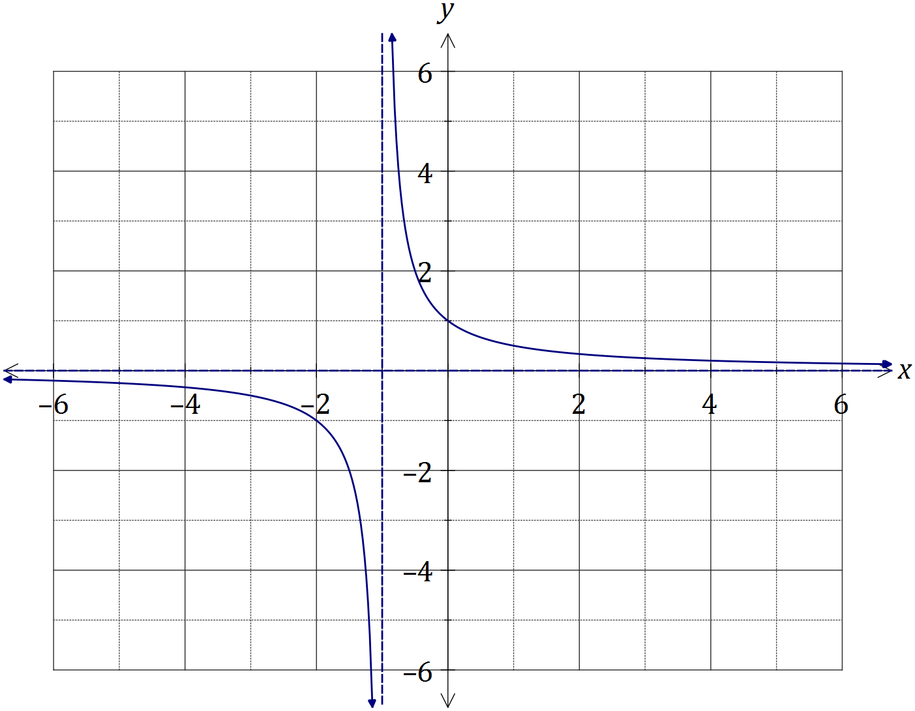

|  |
| --- |
| **Solution** |
| See graph |
| **Specific behaviours** |
| ✓ both asymptotes clear  ✓ passes through (-2, -1) and (0, 1)  ✓ smooth curve, no 'hooking' |

(b) Evaluate the difference quotient $\frac{f\left(x+h\right)-f(x)}{h}$ as $h→0$ to determine the slope of $f(x)$ when $x=2$. (4 marks)

|  |
| --- |
| **Solution** |
| $$m=\frac{\frac{1}{x+h+1}-\frac{1}{x+1}}{h} \text{with} x=2$$ $$=\frac{\frac{1}{2+h+1}-\frac{1}{2+1}}{h}=\frac{\frac{1}{3+h}-\frac{1}{3}}{h} \\ =\frac{3-3-h}{h×3(3+h)} \\ =\frac{-1}{9+3h} \\ =-\frac{1}{9} \text{as} h→0$$ |
| **Specific behaviours** |
| ✓ substitutes and simplifies quotient  ✓ adds fractions in numerator and simplifies  ✓ cancels $h$ in quotient  ✓ substitutes $h=0$ to obtain slope |

Additional working space

Question number: _________